Report on the Visit of 9th Standard Students and Faculty Members of Karmaveer Bhaurao Patil Vidyamandir, Pune to Bharati Vidyapeeth’s College of Engineering for Women, Pune under the SPPU School Connect 2.0 Program of New Education Policy (NEP)

Date: 30/01/2025
Participants: 9th Standard Students and Faculty Members.
Organized by: School Management and Bharati Vidyapeeth’s College of Engineering for Women, Pune
On 30/01/2025, a group of 9th standard students and faculty members from Karmaveer Bhaurao Patil Vidyamandir, Pune, visited Bharati Vidyapeeth’s College of Engineering for Women, Pune, as part of the SPPU School Connect 2.0 program under the New Education Policy (NEP). This program is designed to bridge the gap between school and higher education, providing students with exposure to the engineering field and inspiring them to pursue careers in Science, Technology, Engineering, and Mathematics (STEM).
Warm Welcome and Introduction:
The students and faculty were warmly welcomed by the college’s faculty and staff.
Campus Tour and Department Visits:
Following the welcome, the students embarked on a guided tour of the campus, where they had the opportunity to visit various departments such as Computer Science, Information Technology, and Electronics and Telecommunication Engineering. This provided them with an understanding of the diverse engineering disciplines and the opportunities available in the field of higher education.
The highlight of the tour was the visit to the First Year department. The students explored several well-equipped laboratories, including Engineering Physics, Engineering Chemistry, Engineering Mechanics, Electrical Engineering, and others. They also visited the Drawing Hall, Tutorial Room, and classrooms. The students were particularly impressed by the modern infrastructure and state-of-the-art equipment in the labs. The practical learning environment fascinated them, as they could see firsthand how theoretical concepts in engineering are applied in real-world scenarios. This exposure sparked their curiosity and deepened their interest in pursuing engineering education.
Interactive Session with Faculty:
An interactive session was organized, where faculty members explained the various engineering courses offered at the college. The students were encouraged to ask questions regarding the curriculum, career prospects, and the skills necessary to succeed in engineering. The session provided valuable insights into the future of engineering, and the students were able to clarify their doubts and gain a better understanding of what to expect in higher education.
Conclusion:
The visit to Bharati Vidyapeeth’s College of Engineering for Women proved to be an enriching and inspiring experience for the 9th standard students from Karmaveer Bhaurao Patil Vidyamandir and Junior College. It gave them a closer look at the world of engineering education and practical applications, motivating them to consider pursuing careers in STEM fields. The well-maintained labs, the modern learning environment, and the encouragement from faculty members left a lasting impression on the students, inspiring them to aim for excellence in their future studies.
This initiative under the SPPU School Connect 2.0 program of NEP is an excellent opportunity for students to bridge the gap between school education and higher education, and it fosters a deeper understanding of the importance of STEM education. The visit concluded with students feeling more confident and motivated about their academic futures, particularly in engineering.
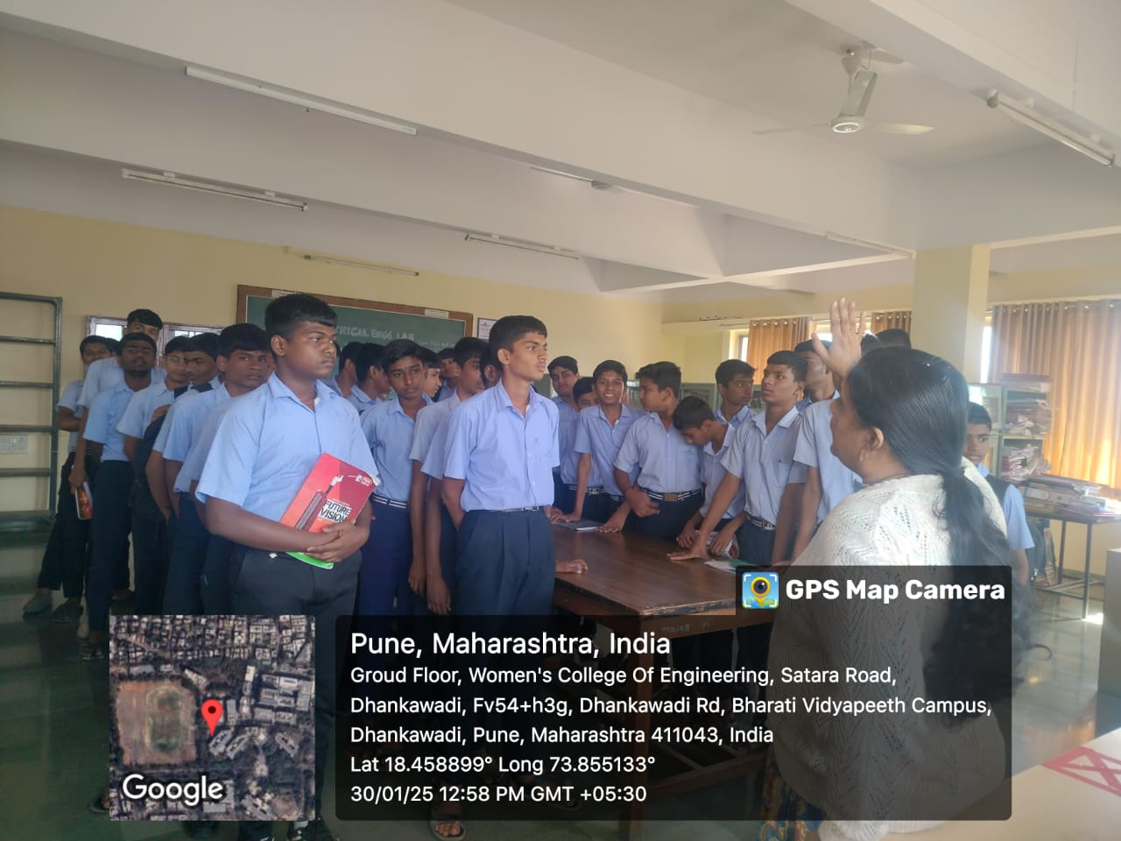 | 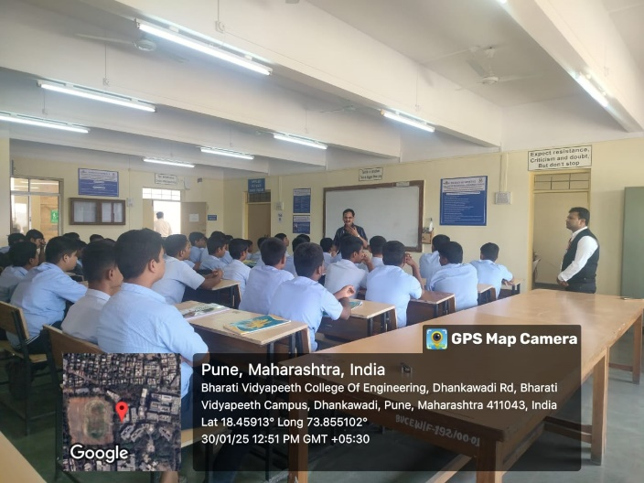
Prof. D.P. Chopade discussing the significance of Basic Electrical Engineering.. | Principal, Prof. Dr. P. V. Jadhav, providing guidance to the students on the future of engineering

